Final Project Proposal

Project Overview
- For my final project I would like to make a fitness tracker based on sports teams that people can use as motivation to work out. Examples of exercises would be
  - Hockey:
    - Every goal for is 10 push-ups
    - Every goal against is 25 sit ups
    - Every time your team loses is 30 squats
    - Every penalty your team takes is 10 burpees
  - Football:
    - Every touchdown is 20 push-ups
    - Every touchdown against is 20 sit-ups
    - Every penalty your team gets is 30 squats
    - Every time your team loses is a 1 mile run/walk
  - Baseball:
    - Every run is 10 push-ups
    - Every run against is 10 sit-ups
    - Every error is 30 squats
    - Every Homerun is 1 mile walk/run
  - Basketball:
    - Every 3 pointer is 10 push ups
    - Every 3 pointer against is 10 sit-ups
    - Every Technical foul is 30 squats
    - Every loss is 10 burpees
- For a MVP the only sports supported will be the ones listed above. The only exercises supported will also be the ones listed above. The quantity can be customized and the teams will be stored in a library and updated if any new teams are added to the leagues.
- The purpose of this application will be to get sports fans off of the couch and exercising while still supporting their teams. This is something that I have been doing for a while now and I have always wanted to develop an application that would make tracking these sports stats easier so that I can focus on watching the team and exercising without also having to keep track of all of these metrics.

Key Features
- The main features of this application will be adding a favorite team for your sport
- Creating a short list of work outs based on events of a game that your team plays in
- Tracking total exercises due and total exercises that the user has completed
- JS will be used to track the users favorite team. The customized workout goals, what is due, what is completed and then a total review for the user to see at the end of each season.
- CSS will be used to make creating workouts, logging workouts or checking workout progress can be used.

Technologies Used
- Variables, data-types, and control flow
- Classes, functions, and objects
- DOM and event/error handling
- API calls and Async JS
  - NHL: https://api-web.nhle.com/v1/
    - Boxscore: /gamecenter/[gameId]/boxscore

  - MLB: https://statsapi.mlb.com/api/v1/
  - NBA: https://stats.nba.com/stats/
  - NFL: https://site.api.espn.com/apis/site/v2/sports/football/nfl/scoreboard
  - https://api-sports.io for one API for all sports
    - Need to create acount
- OOP
- Local storage and session management will also be used

Wireframe or UI Sketch

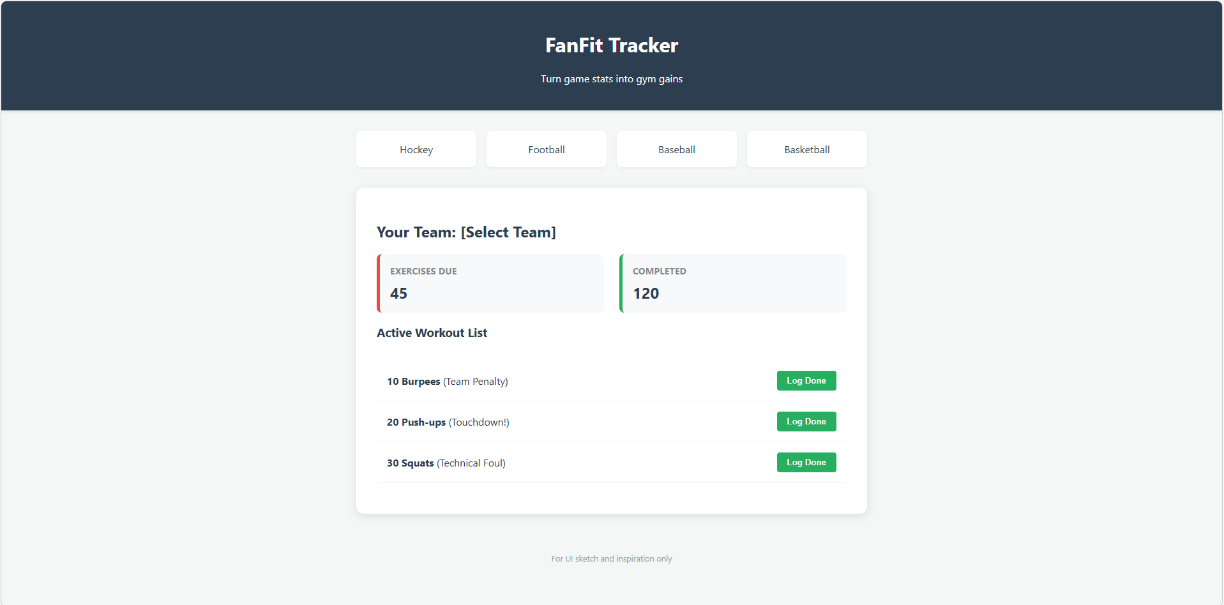

Development Timeline
- 1-2 days to create libraries, for teams for all sports, provided exercises
- 2-3 days to create beta MVP UI
- 2-3 days to create backend to storge local data (progressives and goals)
- 5 days to link backend to frontend
- 5 days for debug/testing

